School to Work Transition Methods:
Educating Students with Severe and Multiple Disabilities Including Deafblindness
SERP 568

Instructors: Rebecca Hartzell and Alison Zagona
Office: College of Education
Phone: 520-621-1462
Email: Hartzell@email.arizona.edu
Office Hours: By Appointment
Recommended faculty: Alison Zagona, Rebecca Hartzell, or Dr. Macfarland
Units: 3

UNIVERSITY OF ARIZONA CATALOG DESCRIPTION
Provides an understanding of effective strategies for promoting the smooth transition of students with disabilities from school to work and adult living.

EXPANDED COURSE DESCRIPTION
This purpose of this course is to present strategies for adaptations, curriculum modifications, and transition planning for individuals who have moderate to severe cognitive, physical, sensory, and behavior disabilities including deafblindness and autism. IDEA transition requirements and related disability legislation will be presented as well as local and state interagency cooperation. Students will learn how to develop transition plans. Expansion of individualized lesson plans will entail collaborative strategies in planning community-based instruction in the domain areas of work, recreation/leisure, domestic living, and general community (e.g., transportation, community services.

Course content will be presented online using D2L with students completing individual work and collaborative team projects. Invited transition specialists and community agency representatives will present course content as well. Two projects of a site visit and transition plan will be included in the coursework.

LEARNING OUTCOMES
Students will
- Describe best practices in transition planning for individuals with severe and multiple disabilities
- Be able to functionally assess individuals with severe and multiple disabilities, including those with deafblindness to prepare for school to work transition.
- Learn how to write transition plans that include goals and objectives that are activity-based, reflect family/individual preferences, and specifically state the skills to be acquired within the timeframe specified.
- Describe key components of self-determination including a system for fostering the development of self-determination skills in students with severe and multiple disabilities.
- Acquire knowledge about and develop systematic teaching procedures in community-based environments that facilitate skill and value-based learning to increase independence and self-determination.
- Establish a system of organization that allows for Person Centered Planning and Student Led IEPs in transition settings.
- Learn how to support desired behavior in a positive and systematic manner while teaching functional skills in community environments.
- Learn collaborative management skills to work with paraeducators and community members in school and community environments.
- Gain knowledge and information about school to work transition strategies, programs, resources, services, interagency cooperation, and current issues.
- Gain knowledge about and contacts with local and state agencies that support transition services for individuals with severe and multiple disabilities including deafblindness.
- Learn how to build employer awareness with a strengths-based and individualized approach to finding meaningful employment.
- Incorporate Assistive Technology into transition planning by considering the student’s individual needs through assessment.

READINGS/TEXTBOOKS
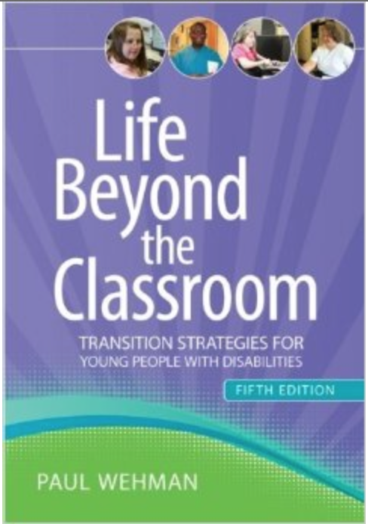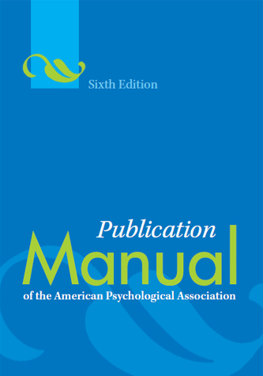
required recommended

Required Readings:

Wehman, P. (2013). Life beyond the classroom: Transition strategies for young people with disabilities (5th ed.). Baltimore: Brookes Publishing Co.

Recommended Readings:

American Psychological Association (2009). Publication manual of the American psychological association (6th ed). Washington, D.C.: Author.

Additional readings will be distributed to supplement session topics.

POLICIES
- Absence policy: All holidays or special events observed by organized religions will be honored for those students who show affiliation with that particular religion. Absences pre-approved by the UA Dean of Students (or Dean’s designee) will be honored.
- Assignment policy: Assignments will be time sensitive; they will be available for a limited amount of time in which the students can complete them. All assignments are due by 11:59 PM on the dates indicated. Any assignment turned in late without prior approval from an instructor may result in the loss of 25% of the total points possible.
- Students who require accommodations for disabilities: If you anticipate issues related to the format or requirements of this course, please contact the instructor. All efforts will be made to ensure full participation in the course. If you determine that formal, disability-related accommodations are necessary, it is very important that to be registered with Disability Resources (621-3268; drc.arizona.edu) and notify the instructor for eligibility for reasonable accommodations.
- Policies regarding expected classroom behaviors: Students are expected to adhere to standards of appropriate online etiquette. Students are expected to use respectful, person-first language in their assignments, competency evaluations, and final comprehensive projects.
- Policies against plagiarism: All assignments must be the original work of the student. Plagiarism is a willful act that will not be permitted. Each student is expected to understand the meaning of plagiarism and demonstrate a high level of academic integrity. Cutting and pasting directly from a website is considered plagiarism. Simply changing a few words in a sentence or phrase also constitutes plagiarism. All students are expected to be familiar with U of A policies, codes, and procedures regarding academic integrity and conduct. Instances of plagiarism or academic dishonesty will be subject to the policies and procedures contained in the U of A Dean of Students Policies, Codes, and Procedures website: http://dos.web.arizona.edu/uapolicies/index.html Any instance of plagiarism may result in an "F" for the course.
- Policies against threatening behavior by students: Students are expected to maintain professional communication within any written or verbal communication with the instructors and other students. University policies are included at http://policy.web.arizona.edu/policy/threaten.shtml
- Course content change policy: Information contained in the course syllabus, other than the grade and absence policies, may be subject to change with reasonable advance notice, as deemed appropriate by the instructors.

REQUIREMENTS
Participation: Students are required to complete weekly reflections in the discussion section of the course. If extenuating circumstances prevent a students from completing an assignment, efforts must be made to contact the instructor. The instructor may administratively drop students who do not log on to the class for two consecutive weeks. If students have trouble with access, or have problems with logging on and participating in the class, students must write to both instructors and get in touch with the appropriate support at the 24/7 help desk at http://the247.arizona.edu

Computer literacy: Students are expected to have a working knowledge of their computer system (e.g. programs, saving, retrieving, printing), and are expected to have ‘working’ knowledge and skills within the D2L environment. If students have difficulty with the D2L site, students are encouraged to check out the help pages within D2L or contact the free D2L helpdesk: http://help.d2l.arizona.edu for assistance. Students will need to download a free copy of Acrobat Reader http://get.adobe.com/reader/.

Submitting Assignments: All assignments will be submitted via the drop box in D2L.

COURSE OUTLINE

Unit 1: Introduction and Course Overview
- Target population, best practices in transition
- Person-first language
- Introduction to paraprofessional responsibilities
Read it! | View it! | Reflect on it! | Do it!
Syllabus, Course Procedures, Unit 1 Overview | See video links under Content tab for Unit 1 View it! | Introduction | Quiz
Unit 2: Best Practices; Teaching Meaningful Skills in Meaningful Environments
- Nothing about me without me
- Social Role Valorization and Natural proportions
- Best practices with paraprofessionals
Read it! | View it! | Reflect on it! | Do it!
Essential Best Practices in Inclusive Schools  Moving Toward Full Inclusion Chapter in Wehman text | See video links under Content tab for Unit 2 View it! | Describe two best practices you hope to implement in your teaching and how these practices are important to transition-age individuals. | Quiz
Unit 3: Assessment for Transition
- Interest inventories, review records
- Overview of ecological assessment
- Role of paraprofessionals in assessments
Read it! | View it! | Reflect on it! | Do it!
Wehman Chapter 10 | See video links under Content tab for Unit 3 View it! | Describe two strategies that classroom teachers can use to assess student learning? Use references in your reflection. | Complete an interest inventory with a student (preferred), friend, or family member.
Unit 4: Introduction to Transition Plans
- Transition legislation
- Key components of a transition plan
- Role of paraprofessionals with transition plans
Read it! | View it! | Reflect on it! | Do it!
Wehman Chapter 1 | Dr. Paul Longmore  Kate Gainor  Disability Rights- It’s our Story | Reflect on the disability rights movement videos. | Quiz

Unit 5: Self Determination
- Definition, Assessments and Instruction
- Promoting self determination through paraprofessionals
- Role of family in self determination
Read it! | View it! | Reflect on it! | Do it!
Wehman Chapter 2 | See video links under Content tab for Unit 5 View it! | Why would it be important for our students to be self-determined? | Complete a self-determination assessment on a student, friend, or family member.
Unit 6: Person Centered Planning
- Individualized planning and Steps to Implement PCP
- Working with paraprofessional to implement PCP
- Role of family in PCP
Read it! | View it! | Reflect on it! | Do it!
Wehman Chapter 4 | See video links under Content tab for Unit 6 View it! | Discuss the value of person centered planning. | Establish a system of organization (checklists, fill in the blank sheets) that will enable you to prepare for a Person Centered Planning meeting.
Unit 7: Student-Led IEPs
- Essential components and strategies for organization
- Collaboration with paraprofessionals preparing for IEPs
- Preparing family for IEPs
Read it! | View it! | Reflect on it! | Do it!
See Links under Read it! Tab for Unit 7 | See video links under Content tab for Unit 7 View it! | Describe what a student led IEP would look like. Why should it be led by the student? | Quiz
Unit 8- Midterm

Read it! | View it! | Reflect on it! | Do it!
Read the Chapter on the disability your student has for your final project (Chapter 16 - 20) | See video links under Content tab for Unit 8 View it! | No reflection this week. Good luck on the midterm! | Sample Transition Plan

Unit 9: Transition Plans Continued- Family and Interagency Collaboration
- Parent and Teacher involvement
- Barriers to and Strategies for Involvement; Improved outcomes
- Supporting paraprofessionals to work within the team
Read it! | View it! | Reflect on it! | Do it!
Wehman Chapter 3 | See video links under Content tab for Unit 9 View it! | What are some barriers for student and parental involvement? How can we as educators overcome them? | Quiz
Unit 10: Preparing students in Post Secondary Settings
- Transition programs
- Community based instruction and service learning
- Best practices for paraprofessionals and peer mentors in transition programs
Read it! | View it! | Reflect on it! | Do it!
Wehman Chapter 15 | See video links under Content tab for Unit 10 View it! | Describe 3 challenges for students with developmental disabilities gaining access to postsecondary education? How can we address that? | Seven Predictor Variables
Unit 11: Transition Plans continued-
Finding Meaningful, Competitive, Customized Employment
- Building employer awareness and “job carving”
- Strengths based and individualized
- Supporting paraprofessionals to identify strengths and employment opportunities
Read it! | View it! | Reflect on it! | Do it!
Wehman Chapter 14 | See video links under Content tab for Unit 11 View it! | Describe 3 common concerns for employers hiring students with special needs and explain how you would address them. | Site Visit Due

Unit 12: Assistive Technology as a Transition Support
- Acquiring and using AT (need and preference)
- Evaluating AT
- Training paraprofessionals on the essential best practices of AT
Read it! | View it! | Reflect on it! | Do it!
Wehman Chapter 12 | See video links under Content tab for Unit 12 View it! | If you were to develop a training or protocol for your paraeducators, what essential components would you include? | Select two AT items that would increase, maintain, or improve the skills of the student for whom you are writing a transition plan.
Unit 13: Housing and Community Living
- Types of supports needed
- Changing paradigms of independent living
Read it! | View it! | Reflect on it! | Do it!
Explore DDD website  Wehman Chapter 6 | See video links under Content tab for Unit 13 View it! | Describe 3 options that are available for students who are ready to make a transition to living independently. | Quiz
Unit 14: Adult Services and Supports
- DDD, Transportation, Vocational Rehab
Read it! | View it! | Reflect on it! | Do it!
Wehman Chapter 13 | See video links under Content tab for Unit 14 View it! | Reflect on the importance of work and explain one model of vocational placement. | Quiz
Unit 15- Final Unit
Final Exam
Final Project- Sample Transition Plan #2

EVALUATION METHODS AND GRADING SCALE

PROJECTS:
Site visit (Unit 11; 15 points)

Sample transition plan (Unit 15; 50 points)

EXAMS:
Midterm exam (Unit 8; 20 points)

Final Exam (Unit 15; 20 points)

Evaluation Methods:
Reflections will be graded using a rubric available under Course Content Overview.

Required Assignments | Points | Points Possible
Unit Assignments:  - 13 Quizzes or assignments (10 points possible each)  - 13 Reflection posts on D2L (15 points possible each) | 25 points each for Units 1-7 and 9-14  15 points only for Units 8 and 15 | 300  30
Exams (2)  - Midterm  - Final | 20 points  20 points | 40 points
Final Project | 50 points | 50 points
Total |  | 420 points
Grading Scale:

90-100% | A
80-89% | B
70-79% | C
60-69% | D
0-59% | F

